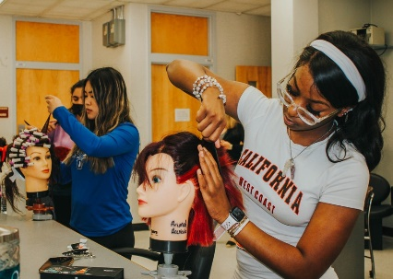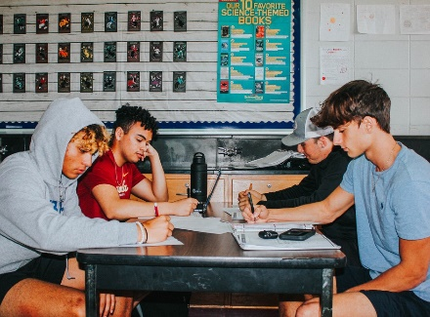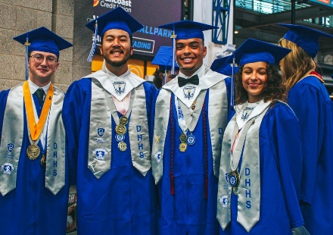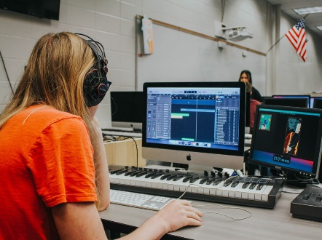

**HOLLINS HIGH SCHOOL**

4940 62nd St. N. (727) 547-7876

St. Petersburg, FL 33709 [www.pcsb.org/hollins-hs](http://www.pcsb.org/hollins-hs)

**JOIN US FOR DISCOVERY NIGHT! November 9, 2023 @ 6pm**

**ABOUT**

Hollins High School is a four-year College and Career Preparatory High School with three distinct academy choices for students to select. We offer the internationally acclaimed college curriculum of Cambridge University with our Advanced International Certificate of Education option, Academy of Entertainment Arts and Academy of Culinary Arts. All students have access to the AICE Curriculum, while AICE Academy students can earn up to 45 college credits within the program and over 60 college credits when combined with our Dual Enrollment selections. Our Academy of Entertainment Arts offers unique strands in music production, film, animation, gaming, 3D-design, and Brand U - where students create their own brand for monetization through various forms of social media. At Hollins High School, you are royalty, and our teachers and staff are prepared, poised and positioned to take your talent to the heights you always imagined and make all your dreams come true.

**POINTS OF PRIDE**

AEA Academy has placed winners in every local, district, state, and national art competition in the last seven years. Two students have earned full scholarships to the University of Southern California's prestigious School of Film.

Our Culinary students have earned over 35 thousand dollars in scholarship money to pursue their passion in the culinary field.

Our Cambridge students have been accepted to Yale, Harvard, Stanford, and Georgetown as well as being well represented in state at the UF, FSU, and USF.

Our Wrestling team has won the district title three of the last five years as well as the PCAC Championship.

Our baseball team won the PCAC Championship and District title in 2022. Our school has a state-of-the-art college green/hub and Student Center attached to a school store where our students design, produce and sell Royal merchandise and gear along with their own imagined and designed clothing and gear. Our Student Center has its very own café for both sit down and drive by refueling.

**SPECIAL SERVICES & PROGRAMS**

AICE Curriculum through University of Cambridge, England

Academy of Entertainment Arts - Music, Film, Animation, Gaming, 3D, Brand U Academy of Culinary Arts

Cosmetology Machining/Robotics JROTC